The Spring 2022 History Department Soirée
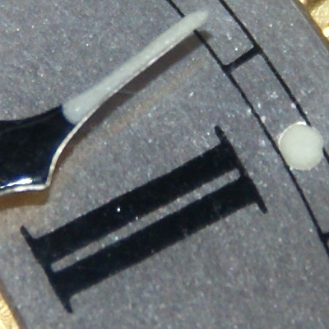
Figure 1. Self-luminous paint that contains radium on an old clock. https://images-of-elements.com/radium.php

Join us for a talk by Dr. Erin Becker-Boris will share her research on the convergence of women, labor, and the environment through a global extractive maritime economy in her talk, “Great Grandma Barrett was a Shining Woman: New York City Radium Dial Painters & Industrial Disease.” Her talk will be followed by three Metropolitan State alumni sharing their thoughts on studying history. There will be time for Q&A and discussion.

Where: Zoom (click here to register in advance, or email history@metrostate.edu to receive the Zoom invitation)
When: 4:30-6:30 p.m., Friday, March 18, 2022

Presenter Biography: Dr. Erin Becker-Boris is a local historian from Long Island, NY. Her work in museums grapples with investing local peoples in their resources (archaeological, historical, and environmental) as stakeholders through outreach, education, and the development of public programming. She has written for Gotham Center for New York History, New York History Blog, Read More Science, H-Net Environment, and Global Maritime History. She is the cohost of the Scholars Beyond the Tower: Conversations from our Fields podcast.

